**Question 37:**

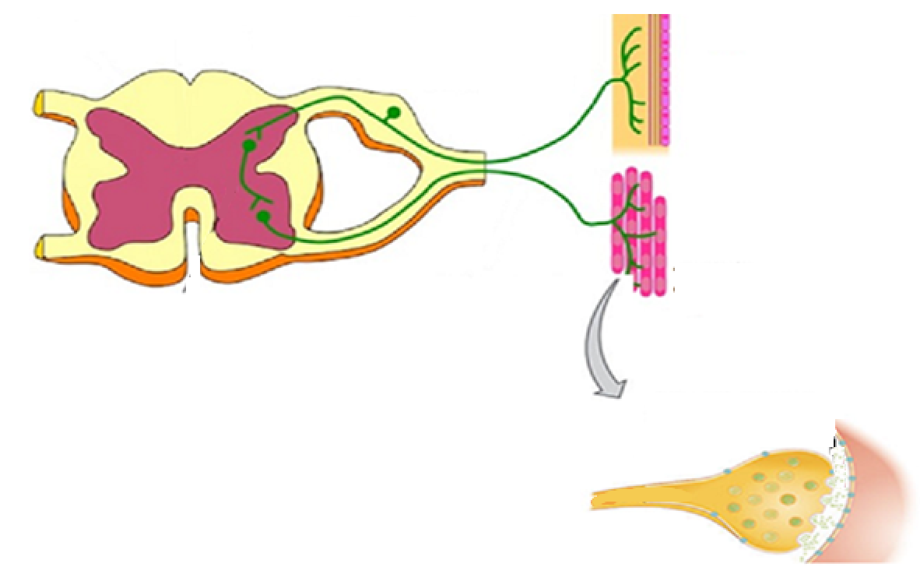

1. What process is shown in the diagram above? (1 mark)  
     
   …………………………………………………………………………………………………………………..
2. Draw arrows on the diagram to indicate the direction in which impulses would flow through this system:

(1 marks)

1. Clearly label the dorsal root with ganglion and where the neurotransmitter would be located on the diagram above. (2 marks)
2. To make it easier to describe the various functions of the peripheral nervous system, it has been classified into divisions and subdivisions.

Complete the following table to classify and describe the neural pathway shown in the diagram above.

|  |  |  |  |  |
| --- | --- | --- | --- | --- |
| Division(s) | Reason for choosing division(s) | Subdivision(s) | Reason for choosing subdivision(s) | Name of neurotransmitter(s) released |
|  |  |  |  |  |

**Question 37:**



1. What process is shown in the diagram above? (1 mark)  
     
   …………………………………………………………………………………………………………………..
2. Draw arrows on the diagram to indicate the direction in which impulses would flow through this system:

(1 marks)

1. Clearly label the dorsal root with ganglion and where the neurotransmitter would be located on the diagram above. (2 marks)
2. To make it easier to describe the various functions of the peripheral nervous system, it has been classified into divisions and subdivisions.

Complete the following table to classify and describe the neural pathway shown in the diagram above.

|  |  |  |  |  |
| --- | --- | --- | --- | --- |
| Division(s) | Reason for choosing division(s) | Subdivision(s) | Reason for choosing subdivision(s) | Name of neurotransmitter(s) released |
|  |  |  |  |  |